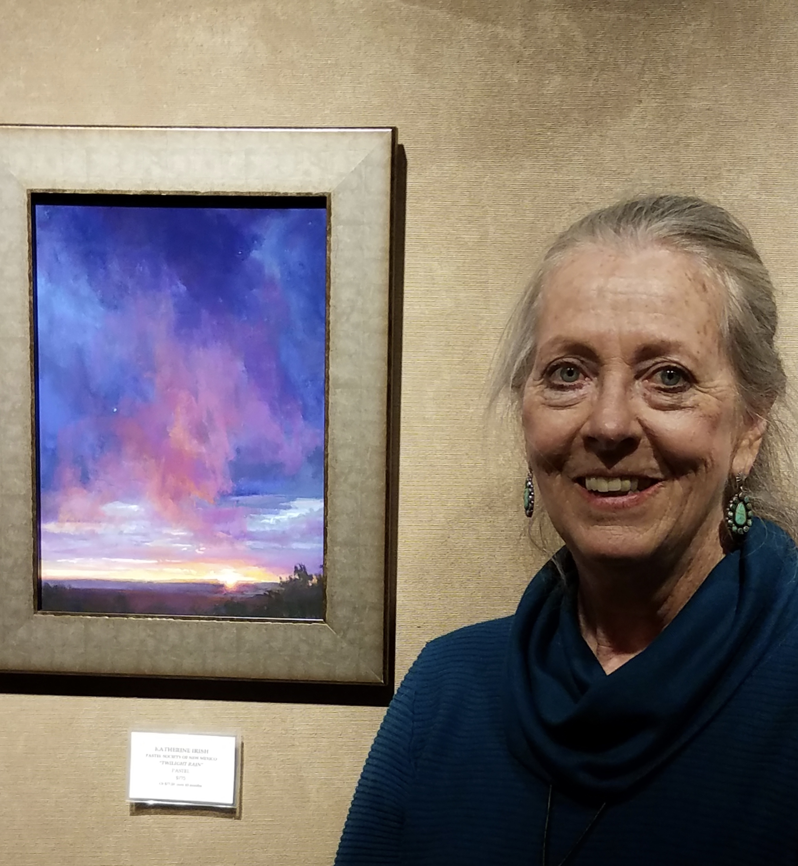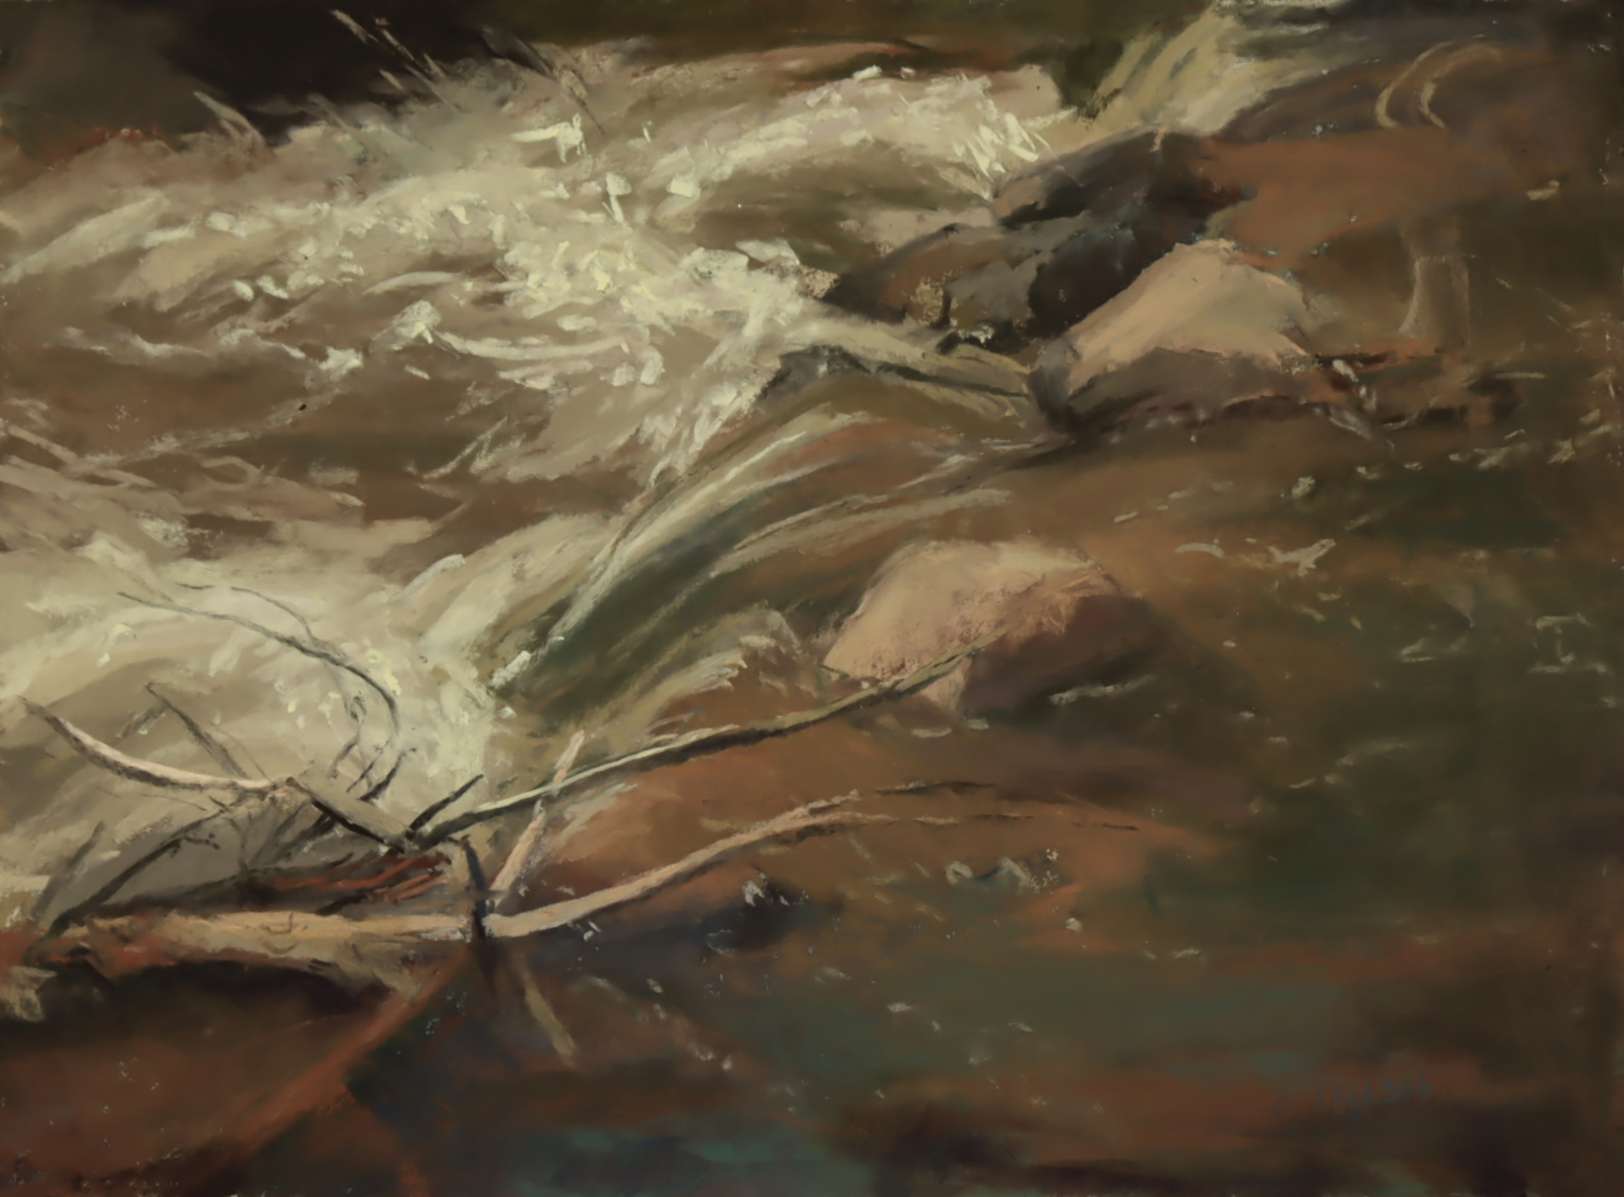
Katherine Irish Trout Stream at Spanish Queen Site, Pastel

Katherine Irish, IAPS/MC, PSA/MP, PSNM/DP, APAA/DP, PSWC, PSSW, SEPS/MOE

Katherine knew she was an artist at an early age. While majoring in art at DePauw University, she attended Tyler School of Art in Rome and interned with Willard Midgette in New York. While in New York, she studied art at the School of Visual Arts and Pratt Institute. She frequented art museums and galleries in New York and Europe. Albert Handell has been an important teacher and mentor in recent years.

Katherine made a conscious decision to contribute beauty to the world through her art. Her desire to paint New Mexico landscapes grew after a painting trip and subsequent relocation from New York to Taos. During that period, she exhibited in galleries in Taos, Scottsdale and Santa Fe, including the San Francisco Museum of Modern Art, Art Rental Gallery. She was active in the art scene in Taos, curating the first three Spirit in Art shows held during the Taos Spring Arts Celebration.

Previously painting in oil, Katherine began to work seriously in pastels in 2002. She continues to find inspiration in New Mexico landscapes, the cobalt blue skies and brilliant reds and greens found in plants and geological formations. Katherine thoroughly enjoys painting outdoors and her association with the Plein Air Painters of New Mexico. Her studio work includes paintings of New Mexico sunsets. Sunsets incorporate many abstract patterns as well as beautiful layers of color. She thinks of herself as a “Skywatcher”. Katherine has focused on the portrayal of light, nuance, emotional connection through the use of color in her work.

Katherine is an award-winning artist who regularly participates in national juried and invitational shows. She was recently awarded Master Pastelist from the Pastel Society of America. She also achieved Masters Circle with the International Association of Pastel Societies and Distinguished Pastelist with the New Mexico Pastel Society and the Arizona Pastel Artists Association. She is a Signature Member of the Pastel Society of the West Coast, the Pastel Society of the Southwest, and a Member of Excellence of the Southeastern Pastel Society. She is also an active member of the Plein Air Painters of New Mexico.

Katherine has won numerous awards in 2021 including First Award of Excellence with the Pastel Society of the Southwest, Second Pplace with the Pastel Society of Colorado, Pan Pastel Award with the Pastel Society of American and an Award of Excellence with the Pastel Society of New Mexico. She exhibits regularly with Women Artists of the West, the American Impressionist Society, and the California Art Club. Her work was shown on the cover and featured in the August 2015 issue of the Pastel Journal. Katherine is represented by Weems Gallery and Framing in Albuquerque, New Mexico.

